Wi-Fi Communication platform

Version 1.0

Table of Contents

1. Introduction 5

1.1 Purpose 5

1.2 Scope 5

1.3 Definitions, Acronyms, and Abbreviations 5

1.4 References 5

1.5 Overview 5

2. Overall Description 6

2.1 product perspective 6

2.2 product functions 6

2.2.1 Add user data to the profile 6

2.2.2 Edit user profile 6

2.2.3 Create a Wi-Fi hotspot 6

2.2.4 Stop created Wi-Fi hotspot. 6

2.2.5 Connect to a Wi-Fi network 6

2.2.6 Connect to a Wi-Fi network 6

2.2.7 Disconnect a Wi-Fi network 6

2.2.8 See the connected devices (as contacts) 6

2.2.9 Start a private chat 6

2.2.10 Start a group chat 6

2.2.11 Send a text message 6

2.2.12 Send files 6

2.2.13 See old messages 6

2.3 User characteristics 6

2.4 Constraints 6

2.5 assumptions and dependencies 6

2.6 requirements subsets 7

2.6.1 Functional requirements 7

2.6.2 Usability 7

2.6.3 Reliability 7

2.6.4 Performance and security 7

2.6.5 Supportability 7

3. Specific Requirements 8

3.1 Functionality 8

3.1.1 Functional Requirement 1 9

3.1.2 Functional Requirement 2 9

3.1.3 Functional Requirement 3 9

3.1.4 Functional Requirement 3 9

3.1.5 Functional Requirement 5 9

3.1.6 Functional Requirement 6 10

3.1.7 Functional Requirement 7 10

3.1.8 Functional Requirement 8 10

3.1.9 Functional Requirement 9 10

3.1.10 Functional Requirement 10 10

3.1.11 Functional Requirement 11 11

3.1.12 Functional Requirement 12 11

3.2 Usability 11

3.2.1 Usability Requirement 1 11

3.2.2 Usability Requirement 2 11

3.3 Reliability 12

3.3.1 Reliability Requirement 1 12

3.3.2 Reliability Requirement 2 12

3.3.3 Reliability Requirement 3 12

3.3.4 Reliability Requirement 4 12

3.3.5 Reliability Requirement 5 12

3.3.6 Reliability Requirement 6 12

3.4 Performance and Security 12

3.4.1 Performance Requirement 1 12

3.4.2 Performance Requirement 2 13

3.4.3 Performance Requirement 3 13

3.4.4 Performance Requirement 4 13

3.5 Supportability 13

3.5.1 Supportability Requirement 1 13

3.5.2 Supportability Requirement 2 13

3.5.3 Supportability Requirement 13

3.6 Design Constraints 14

3.6.1 Design Constraint 1 14

3.6.2 Design Constraint 2 14

3.6.3 Design Constraint 3 14

3.6.4 Design Constraint 4 14

3.6.5 Design Constraint 5 14

3.7 On-line User Documentation and Help System Requirements 14

3.8 Purchased Components 14

3.9 Interfaces 15

3.9.1 User Interfaces 15

3.9.2 Hardware Interfaces 16

3.9.3 Software Interfaces 16

3.9.4 Communications Interfaces 17

3.10 Database Requirements 17

3.11 Licensing, Legal, Copyright, and Other Notices 17

3.12 Applicable Standards 17

4. Supporting Information 17

# Introduction

This section gives a scope description and overview of everything included in this SRS document. It includes the purpose, scope, definitions, acronyms, abbreviations, references, and overview of the SRS

## Purpose

Purpose of this document is giving a detailed description on “Wi-Fi communication system” named “flying bird” software. This will illustrate the purpose of this system, development needs, constraints, interface and interactions with other external applications, functionalities and expected performance of this system. This document is intended to be proposed to the developer to get the correct idea of the system to be implemented and the users who wish to provide feedback on the system.

## Scope

“flying bird” the Wi-Fi communication platform system is a windows operating system based system for offline communication via Wi-Fi. This will provide functionality to send and receiving files and text in the network.

This application is mainly focused on easiness of using. It tries it best to provide a non-hesitating network using experience to the users.

This needs two or more computers with Wi-Fi features and those should be .net installed on the machines.

This is going to design for work with using an existing network or if there is not a network create a network by a hotspot of one of the users. So it won’t be a problem if there aren’t any network around.

## Definitions, Acronyms, and Abbreviations

|  |  |
| --- | --- |
| **Term** | **Description** |
| UI | User interface |
| OS | Operating system (here it is Windows XP or above) |
| User | Person who is using this system |

## References

[1] IEEE Software Engineering Standard Committee, "IEEE Std 830-1998, IEEE Recommended Practice for Software Requirement Specification," October 20, 1998

## Overview

Remainder of this document includes two heading topics “2. Overall description” and “3. Specification requirements” and “4. Supporting information”. Chapter 2 provides an overview of the system functionalities. In there it expresses the constraints and assumptions of this system.

Chapter 3 provides the requirement specification in normal language as detailed terms. It provides software components, interfaces and constraints there with details.

Section 4 contains table of contents, index and appendixes.

# Overall Description

## product perspective

the system will consist of data transferring functions. Users can use this as a normal chat application. User can type text and send it to the selected user or group message box. After send the message it is going to the required destination through the Wi-Fi network.

File sharing also should work as that. In there users should select the files that they want to send and do the same.

The receiver gets the messages as a normal messenger with a notification sound. Then he can see the message from his message box.

## product functions

### Add user data to the profile

### Edit user profile

### Create a Wi-Fi hotspot

### Stop created Wi-Fi hotspot.

### Connect to a Wi-Fi network

### Connect to a Wi-Fi network

### Disconnect a Wi-Fi network

### See the connected devices (as contacts)

### Start a private chat

### Start a group chat

### Send a text message

### Send files

### See old messages

## User characteristics

Here there is only one kind of user. Those who use this application are in one level. A user can use this by adding the user data to the profile and it is not compulsory to create the user profile by user to use this.

## Constraints

There is no usage constraints.

## assumptions and dependencies

User profile I created when the application starts at first. User account is created based on MAC address. All the other details can be changed except MAC address for a user.

## requirements subsets

### Functional requirements

### Usability

### Reliability

### Performance and security

### Supportability

# Specific Requirements

## Functionality

### Functional Requirement 1

**ID: FR1**

TITLE: Add user data to the profile

DESCRIPTION: A user should be able to add the data (name, profile picture) to his/her application profile. When the user starts the application at the first time it he/she needs to add his profile for other’s recognition purpose. This is not compulsory. User should be able to use the application either without making the profile.

DEPENDENCY: None

### Functional Requirement 2

**ID: FR2**

TITLE: Edit user profile

DESCRIPTION: A user should be able to edit his/her profile details. If the user wishes to change his profile picture or his name, there should be the functionality to change them.

DEPENDENCY: FR1

### Functional Requirement 3

**ID: FR3**

TITLE: Create a Wi-Fi hotspot.

DESCRIPTION: A user should be able to create a Wi-Fi hotspot to make a network if they are not already in a network. This happens every time when the user needs to use the app if they are not in a network.

DEPENDENCY: None

### Functional Requirement 3

**ID: FR3**

TITLE: Stop created Wi-Fi hotspot.

DESCRIPTION: User should be able to stop created Wi-Fi hotspot when the communication has finished and if user wish to close the hotspot.

DEPENDENCY: FR3

### Functional Requirement 5

**ID: FR5**

TITLE: Connect to a Wi-Fi network

DESCRIPTION: A user should be able to connect to the required Wi-Fi network using this system. When users need to communicate they should connect to a network. It can be a created hotspot or a Wi-Fi network they have in the premises.

DEPENDENCY: FR3 if they haven’t an accessible Wi-Fi network in the premises.

### Functional Requirement 6

**ID: FR6**

TITLE: Disconnect a Wi-Fi network

DESCRIPTION: A user should be able to disconnect a Wi-Fi connection using this system. This can be happened after the communication ends and if the user wishes to disconnect the connected network.

DEPENDENCY: FR5 or connected by OS Wi-Fi connecting function.

**Note:** FR, FR4, FR4 and FR5 are operating system integrated functionalities. But for the easiness of the user it is expected to have these functionalities in this software system too.

### Functional Requirement 7

**ID: FR7**

TITLE: See the connected devices (as contacts)

DESCRIPTION: A user should be able to see the connected devices in the network as contacts names. If contacts names haven’t been added their IP address and MAC address should be shown. Before starting a conversation this happens for select the needed receiver at another end.

DEPENDENCY: None

### Functional Requirement 8

**ID: FR8**

TITLE: Start a private chat

DESCRIPTION: A user should be able to start a chat with connected users to the network. This is done by selecting the required receiver from contact list.

DEPENDENCY: FR5, FR7

### Functional Requirement 9

**ID: FR9**

TITLE: Start a group chat

DESCRIPTION: A user should be able to create a group chat with the connected users in the network. This is done by selecting the receivers from contact list.

DEPENDENCY: FR5, FR7

### Functional Requirement 10

**ID: FR10**

TITLE: Send a text message

DESCRIPTION: A user who has joined to a chat with another user or a group should be able to send text messages. Text is typed in text box in the chat UI. It should be done by pressing the send button in the chat UI.

INPUT: Text message

OUTPUT: send to the selected receiver/group of receivers

DEPENDENCY: FR8 or FR9

### Functional Requirement 11

**ID: FR11**

TITLE: Send files

DESCRIPTION: A user who has joined to a chat with another user or a group should be able to send file messages. (without file type constraints). It can be multiple files or one file, should be at least 5 files in one row. It should be done by pressing the send button in the chat UI.

INPUT: Any kind of file type

OUTPUT: Send to the selected receiver/group of receivers

DEPENDENCY: FR8 or FR9

### Functional Requirement 12

**ID: FR12**

TITLE: See old messages

DESCRIPTION: A user should be able to see old messages that he/she have received and sent. By selecting another contact or group from the contact list.

DEPENDENCY: None

## Usability

### Usability Requirement 1

**ID: UR1**

TITLE: Training time for normal user is 1 hour

DESCRIPTION: For a user who are not familiar with chat applications and not having an idea about IP address or Mac address this system should be familiar without making hesitations. It is expected to get familiar in about 1 hour for the normal user.

### Usability Requirement 2

**ID: UR2**

TITLE: Training time for power user is 1 hour

DESCRIPTION: For a user who are familiar with chat applications and having an idea about IP address and Mac address this system should be familiar very easily. It is expected to get familiar in about 15 minutes for the power user.

**Note:** The system’s one of the main focused area is easiness of the users. So the network layer technologies should be hide from users as much as possible and they should feel how the required work do by seeing the system.

## Reliability

### Reliability Requirement 1

**ID: RR1**

TITLE: Availability

DESCRIPTION: Expected percentage of time available for this system is 100%. After released for use it should work offline and there is no reason not to be unavailable.

### Reliability Requirement 2

**ID: RR2**

TITLE: Mean Time Between Failures (MTBF)

DESCRIPTION: It is expected to work 24h constantly without failure. MTBF=24h.

### Reliability Requirement 3

**ID: RR3**

TITLE: Mean Time To Repair (MTTR)

DESCRIPTION:

### Reliability Requirement 4

**ID: RR4**

TITLE: Accuracy

DESCRIPTION: Expected accuracy is 100%. As a communication application it should deliver the correct messages.

### Reliability Requirement 5

**ID: RR5**

TITLE: Maximum Bugs or Defect Rate

DESCRIPTION:

### Reliability Requirement 6

**ID: RR6**

TITLE: Bugs or Defect Rate

DESCRIPTION:

## Performance and Security

### Performance Requirement 1

**ID: PR1**

TITLE: Response time for a transaction

DESCRIPTION: Maximum of 3seconds response time is expected.

### Performance Requirement 2

**ID: PR2**

TITLE: Transactions per second

DESCRIPTION: With human performance it is not needed a high transaction frequency. 5 transactions per second is expected.

### Performance Requirement 3

**ID: PR3**

TITLE: Resource utilization

DESCRIPTION: Should be a simple application.

Hard disk space <= 100mb,  
Ram usage at text message chat<=150mb.  
Ram when file sharing <= 400mb.

### Performance Requirement 4

**ID: PR4**

TITLE: Security

DESCRIPTION: this application should use suitable encryption method for security. The data it communicates should only be able to read by the required person.

## Supportability

### Supportability Requirement 1

**ID: PR1**

TITLE: Application extendibility

DESCRIPTION: Application should be implemented in a way that new functions and new add ones can easily be integrated.

### Supportability Requirement 2

**ID: PR2**

TITLE: Maintainability

DESCRIPTION: Coding style and naming should be in a way that new

### Supportability Requirement

**ID: PR3**

TITLE: Testability

DESCRIPTION: Application should support testing functionality for the implementations.

## Design Constraints

### Design Constraint 1

**ID: DC1**

TITLE: Software language

DESCRIPTION: C# should be the programming language.

### Design Constraint 2

**ID: DC2**

TITLE: Development tools

DESCRIPTION: Visual studio 2017

### Design Constraint 3

**ID: DC3**

TITLE: Hardware limitations

DESCRIPTION: Minimum features for the computer: 1GHz Pentium 4, 512MB Ram, Wi-Fi adapter should be run the system

### Design Constraint 4

**ID: DC4**

TITLE: Application language

DESCRIPTION: this application should only use English language for UI.

### Design Constraint 5

**ID: DC5**

TITLE: Application theme

DESCRIPTION: this application should follow the color blue as the system theme.

## On-line User Documentation and Help System Requirements

Online help manual for users is expected for the system in the software download site and offline simple manual is expected integrated with software.

## Purchased Components

Purchased components are not expected.

## Interfaces

### User Interfaces

There are main 2 user interfaces in the application. Those are chat background and settings background.

This application theme should be followed by blue color.

#### Chat background

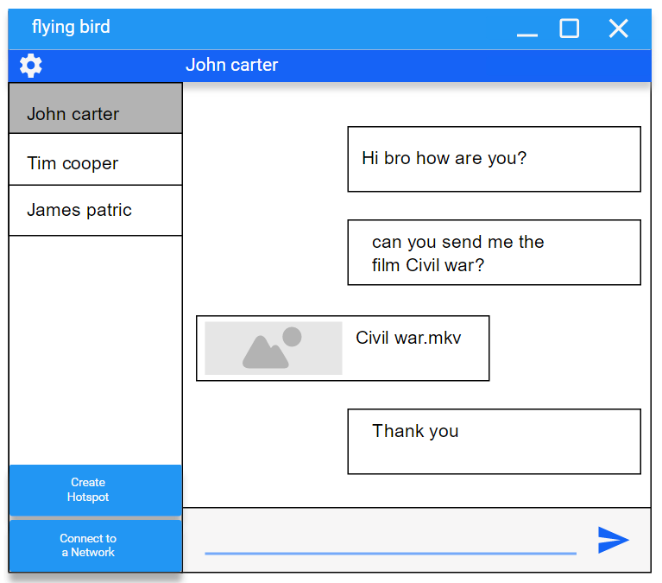

Figure 1- Chat background UI

These UI interfaces are for getting the idea of the required UI interface. It is free to change the design for needs and this chat display template design should be followed for the system.

#### Settings background

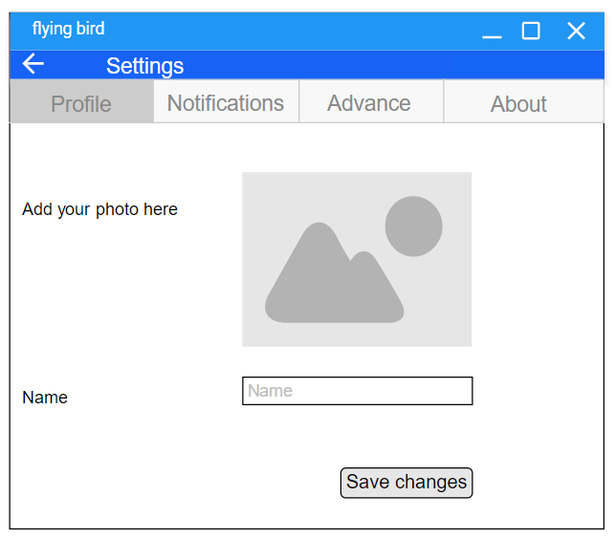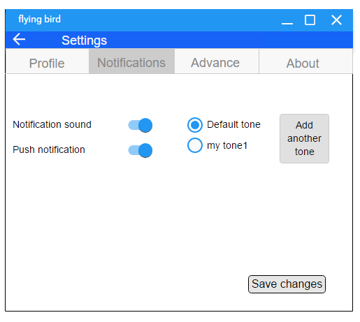

This settings page should be followed for the settings page in the system. The tabbed separated sections should be there to easy understanding of the user.

### Hardware Interfaces

The pc should have a Wi-Fi adapter integrated and should be installed required Wi-Fi drivers.

### Software Interfaces

This system is only run in windows pc.

User’s pc should have .net installed.

This system is not expected any purchased components or components reused from another application. But it is expected to add outside of the scope subsystem for voice recording in the development of second step of this application.

### Communications Interfaces

LAN is the communication media in the system. IP based communication is done through the network mainly focused on Wi-Fi.

## Database Requirements

Required data will be saved as data objects and won’t use SQL databases.

User data, another user’s data and old messages should be saved as consistent data objects.

## Licensing, Legal, Copyright, and Other Notices

## Applicable Standards

No application standards.

# Supporting Information